**Here are the steps to submit PF account's nomination details online:**

**Step 1:** Open EPFO portal - unifiedportal-mem.epfindia.gov.in and login by using your UAN and password

**Step 2**:  Click on 'Manage' tab and then click on e-nomination option

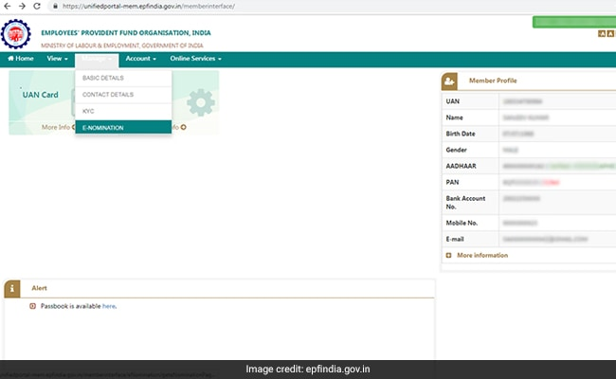

**Step 3:** Your details like UAN, name, date of birth, gender etc., are displayed. Provide your 'current and permanent address' details here. Click on save

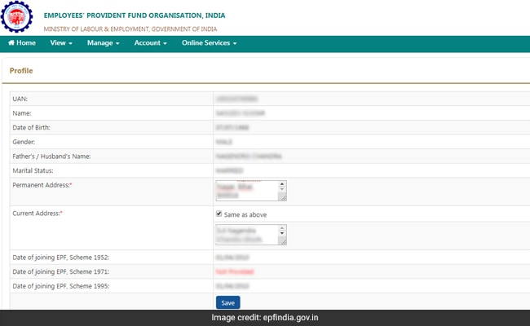

**Step 4:**Now, click on 'yes' to update family declaration

**Step 5:** Go to 'add family member(s)' and add the details of your family members whom you want to nominate. Here, you need to enter the names, date of birth, relation and address of the nominee. You can even add more than one nominee by clicking on 'adding the row'. In case of minor as a nominee, you need to assign a guardian

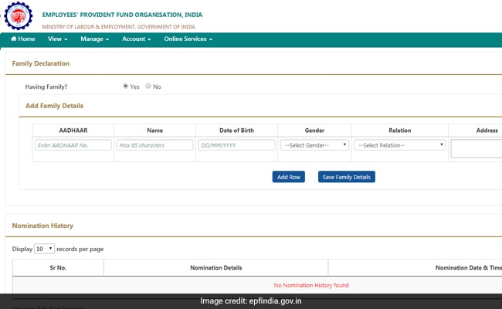

**Step 6:** Go to 'nomination details' and declare the total amount of share among your nominees. In case, you would like to nominate only one member of your family as your nominee then you can declare 100 per cent as the share

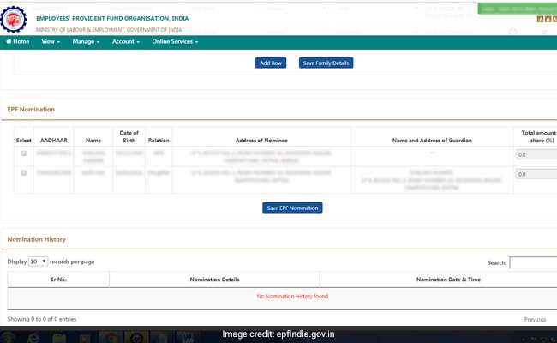

**Step 7:**  Click on 'Save EPF nomination' button

**Step 8:** Now, click on e-sign button to generate OTP, which will be sent to the mobile number that is linked to the Aadhaar card. The Aadhaar e-sign facility helps in approving the e-nomination form. Enter the OTP

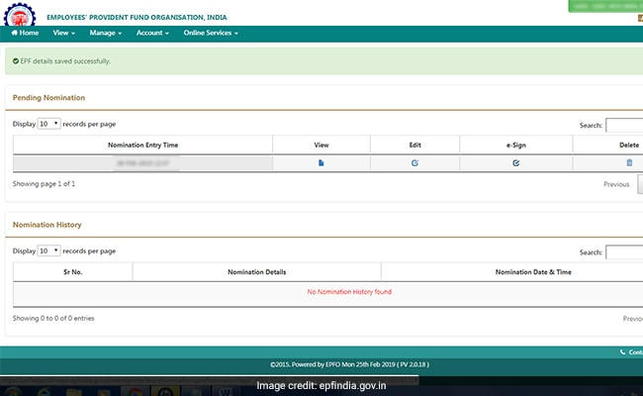

With this, the e-nomination gets registered with the EPFO. There is no need to send any physical document to the employer or ex-employer after the online nomination is done.