**Steps for UAN activation through UAN Member Portal**

Only having a UAN number or an account is not enough. If you want to avail the benefits of UAN, you will have to activate your UAN number. You can activate your UAN number on the unified EPFO portal as per the step-by-step process given below.

* Click on the link: <https://unifiedportal-mem.epfindia.gov.in/memberinterface/>
* Click on ‘Activate your UAN’ which will be below the ‘Login’ column of the page.

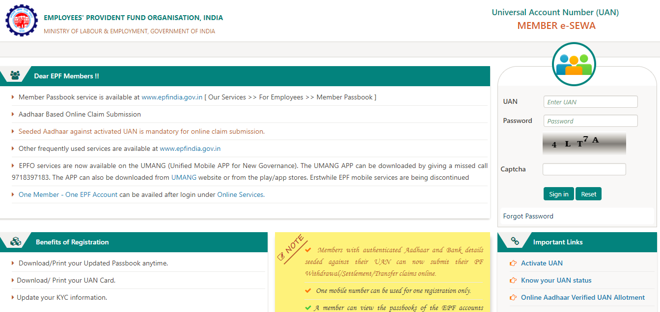

UAN Activation Guide

* You will be redirected to the page given below

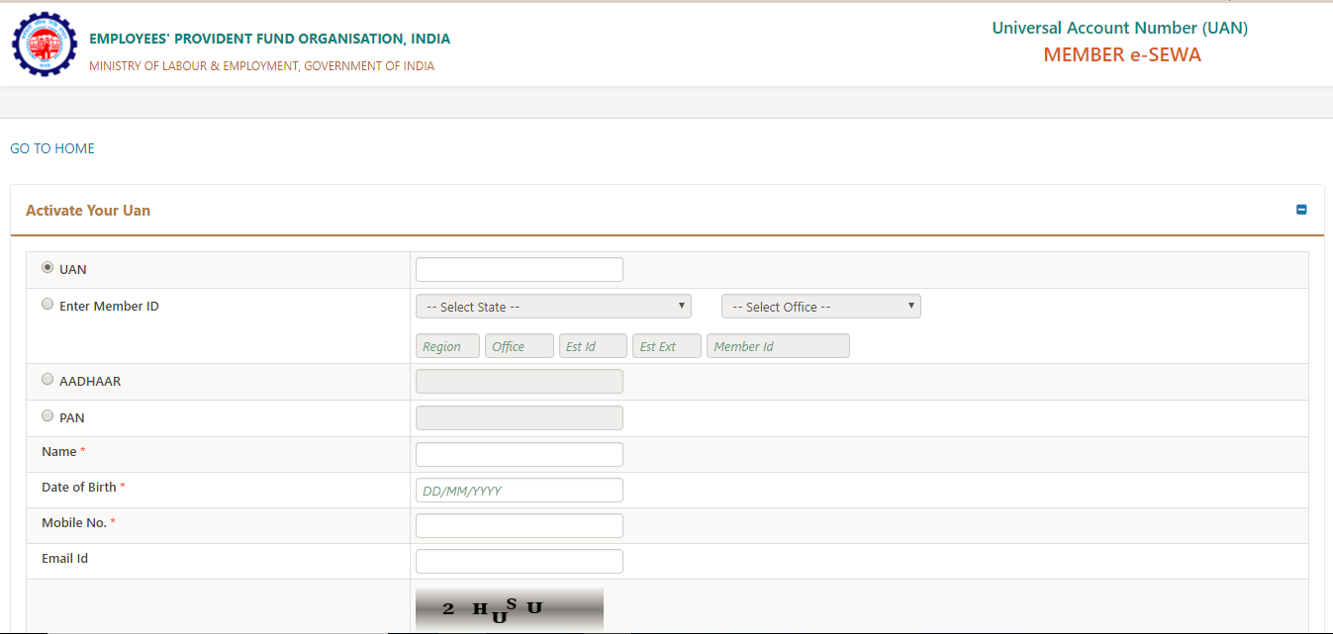

* In this page you are required to enter your UAN, Name, Date of Birth, Mobile No and the Captcha Code and then click on ‘Get Authorization Pin’. You will receive the pin on your mobile number.
* Under the Disclaimer section, click on the ‘I Agree’ checkbox and then enter the OTP that you have received on your mobile number. Click on the ‘Validate OTP and Activate UAN’ button.

After your UAN is activated, you will receive a password on your registered mobile number which will be used for accessing your UAN account.