### Overview of Steps to Change Mobile Number in UAN if forgotten Password and Mobile Number Changed

* **Go to UAN website of EPF at** [UAN  New Website](https://unifiedportal-mem.epfindia.gov.in/memberinterface/)
* Click on **Forgot Password.**
* Enter your  UAN number and Captcha. Click on **Verify.**
* The mobile number mapped to your UAN will be shown. If you want to change the mobile Number you can click on ***No***.
* You will see the screen asking for your Name, Date of Birth, Gender. Click on Verify.If you get an error such as Details not matching, check with your employer as to which Aadhaar Number or PAN number is linked with your UAN.
* Validate your details against Aadhaar or PAN. Click on ***Verify*** near the Document number. If you get Details not matching error, check with your employer as to which Aadhaar Number or PAN number is linked with your UAN.
* If you see Details Validated then you can enter a new mobile number. Click on Get OTP.
* Once you enter OTP sent to your new mobile number, you will enter your new password twice.
* You will see Password changed successfully message. You can click on Login to log with your new password.

### Steps to Change Mobile Number in UAN in Detail in UAN if forgotten Password and Mobile Number Changed

The UAN is a 12-digit number allotted to each Employee Provident Fund member by the Employee Provident Fund  Organization(EPFO) which gives him control of his EPF account and minimizes the role of employer. UAN acts as an umbrella for the multiple Employee Provident Fund Numbers or Member Ids allotted to an individual by different employers. The idea is to link multiple Employee Provident Fund Number of a person to single Universal Account Number. Our article [UAN or Universal Account Number and Registration of UAN](https://www.bemoneyaware.com/blog/uan-universal-account-number-registration-of-uan/) discusses it in detail.

Steps to Change Mobile Number in UAN  in Detail with images is given below.

**Go to EPFO website at** [UAN: Home](https://unifiedportal-mem.epfindia.gov.in/memberinterface/)

Click on **Forgot Password**as shown in image below

[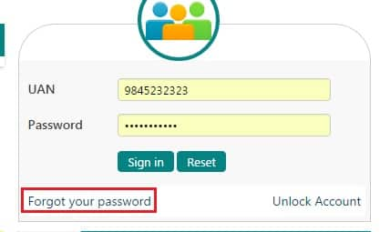](https://www.bemoneyaware.com/blog/wp-content/uploads/2017/01/uan-forgot-password.jpg)

UAN Forgot Password

Enter your  UAN number and Captcha (in the image below Captch is wines) as shown in the image below. Click on **Verify**

[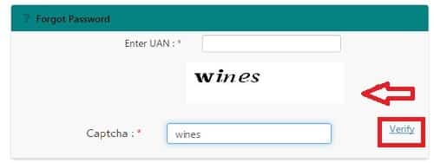](https://www.bemoneyaware.com/blog/wp-content/uploads/2017/01/uan-forgot-password-verify-captcha.jpg)UAN to change password Verify Captcha

The mobile number mapped to your UAN will be shown. If you want to change the mobile Number you can click on ***No***.

[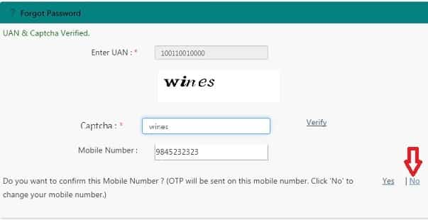](https://www.bemoneyaware.com/blog/wp-content/uploads/2017/01/uan-change-mobile-number.jpg)UAN Change Mobile number

You will see the screen asking for your Name, Date of Birth, Gender, KYC Type, and Document Number. Enter your details. Click on ***Verify*** near the Document number.

[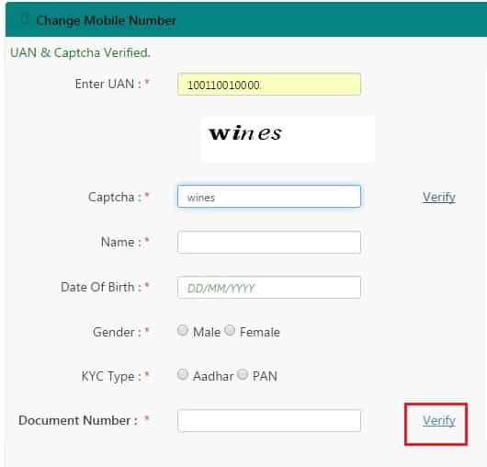](https://www.bemoneyaware.com/blog/wp-content/uploads/2017/01/uan-change-mobile-number-kyc-details.jpg)UAN change mobile number Enter KYC details

Enter your new mobile number. Click on Get Authorized Pin. Pin will be sent to your new Mobile number.

[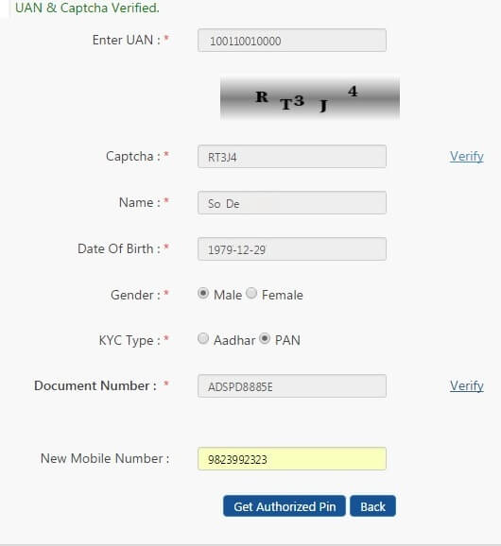](https://www.bemoneyaware.com/blog/wp-content/uploads/2017/01/uan-change-mobile-number-change-password.jpg)UAN Change mobile Number to Change Password

If your Verification fails, as it did for us, then you might get following error message. **Then contact your employer for the details that map to your UAN.**

[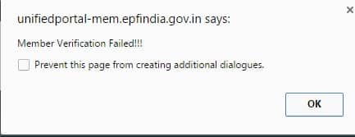](https://www.bemoneyaware.com/blog/wp-content/uploads/2017/01/uan-failed-member-verification.jpg)