**PF Transfer Online – Procedure for EPF Transfer through EPFO Portal**

Employee Provident fund (EPF) is an ideal investment option for any salaried individual owing to its E-E-E (exempt-exempt-exempt) nature. Investment in EPF, interest from EPF and withdrawal from EPF after 5 years is exempt.

Once an individual starts his career by taking up employment in any of the PF registered organisation, an employee would be registered for PF purpose and both employee and employer contributions to employee’s PF and the fund earns interest till withdrawal. Further, it is not uncommon especially in early or mid-years of the career, to switch job for various reasons with or without break. In such scenarios, what happens to the PF account of the employee already created with the previous employer?

The employee will have two options in such cases.

1) Employee’s contribution with interest can be withdrawn if the employee continues to be on break for upto 60 days, or

2) Transfer the balance to the current employer

As already mentioned, in order to make it an ideal saving for retirement it is always better to transfer the PF balance instead of withdrawing. This is also advisable from the tax standpoint as withdrawal of PF within 5 years of continuous service attracts tax.

The Employees’ Provident Fund Organisation (EPFO) has been taking several measures to simplify the operation of EPF account both for employer and employees. EPFO introduced [Universal Account Number (UAN)](https://cleartax.in/s/universal-account-number) which acts as an umbrella for the multiple Member Ids allotted to an individual by different employers. UAN enables linking of multiple EPF Accounts (Member Id) allotted to a single member. UAN offers a bouquet of services like dynamically updated UAN card, updated PF passbook including all transfer-in details, facility to link previous members’ ID with present ID, monthly SMS regarding credit of contribution in PF account and facility for auto-triggering transfer request on change of employment.

Further, keeping up with technology revolution, EPFO is also striving towards making all the process related to EPF electronic, more specifically PF transfer and withdrawal of PF which are generally tedious and time-consuming.

While the PF transfer was possible online earlier under ‘Online Transfer Claim Portal’, with the introduction of UAN, the process of transfer is revised and shifted under ‘unified portal’. However, in order to make online PF transfer, following need to be ensured:

i. The member should have activated his UAN in UAN portal and mobile number used for activation should also be active

ii. Bank account and bank IFSC code of employee should be seeded against the UAN  Seeding Aadhar number and PAN against UAN is not mandatory for raising transfer claims.

iii. The employer should have approved the e-KYC

iv. The previous/current employer should have digitally registered authorised signatories in EPFO

v. PF account number of both previous and current employment of an employee should be entered in EPFO database

vi. Only one transfer request against the previous member ID can be accepted

vii. Personal information and PF account related information is shown in EPFO should be correct

Now we know that PF transfer can be made online and above criteria need to be fulfilled. Let us understand the procedure step by step with the help of screenshots:

**Step 1**

Login to [Unified portal (member interface)](https://unifiedportal-mem.epfindia.gov.in/memberinterface/) by using your credentials i.e., UAN number and password

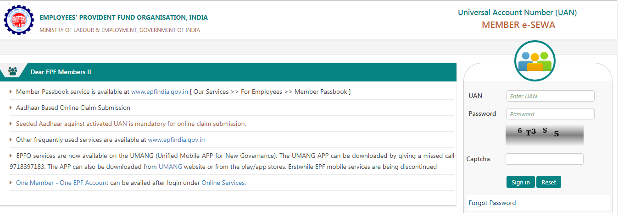

**Step 2**

After login, click on ‘One Member – One EPF Account (Transfer Request)’ under Online Services

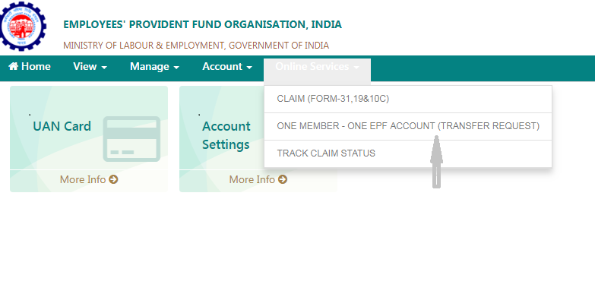

**Step 3**

**Verify personal information and PF account for present employment:**

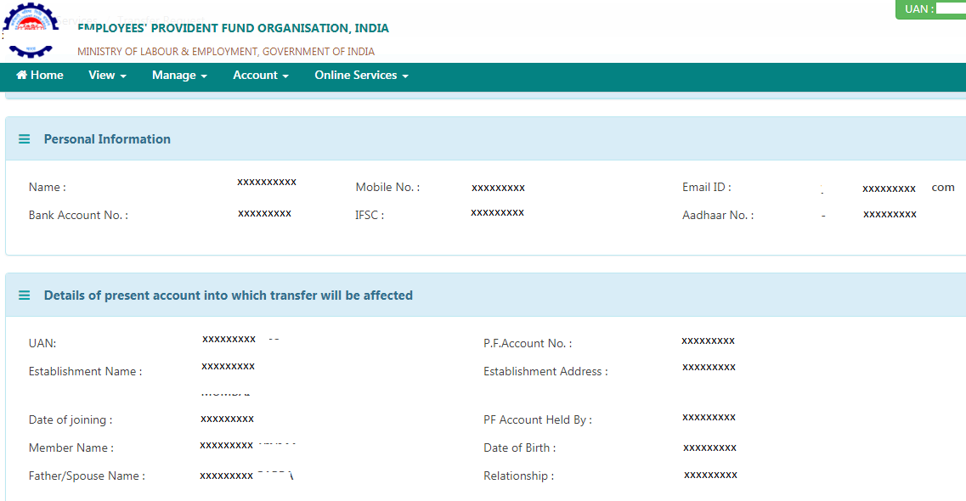

**Step 4**

**PF account details of previous employment would appear on clicking on ‘Get details’ below.**

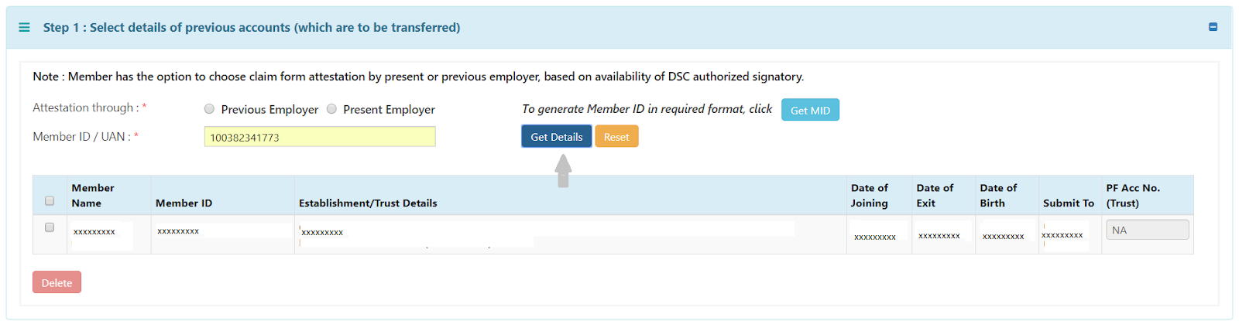

**Step 5**

**You have the option of choosing either your previous employer or current employer for attesting the claim form based on the availability of authorised signatory holding DSC. Choose either of the employers and provide member id/UAN:**

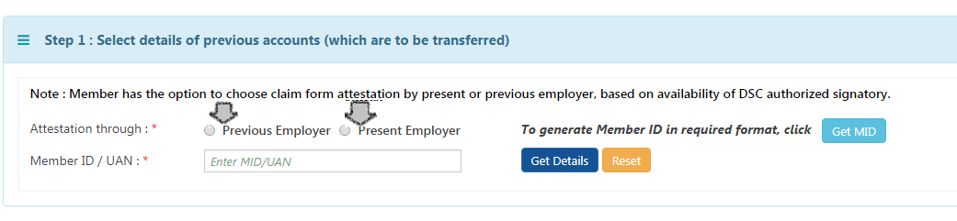

**Step 6**

**In the next step, click on ‘Get OTP’ to receive OTP to UAN registered mobile number and enter the OTP and click on submit.**

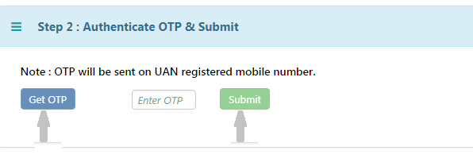

The employer will digitally approve your EPF transfer request by accessing employer interface of the unified portal

Fill up [Form 13](https://www.spmcil.com/UploadDocument/Form%2013-Transfer%20of%20EPF%20Account.ef23ef33-f252-4e0e-907c-133b2ed861e0.pdf) with details including PF number from both previous and current employer and download the transfer claim (pdf format). Submit the physical signed copy of the online PF transfer claim form to the selected employer within a period of 10 days.